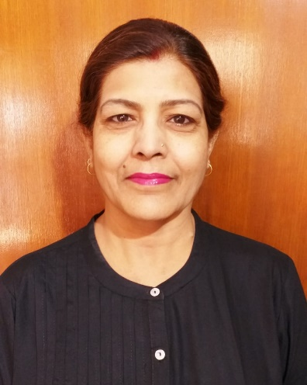
Shweta Jha
Consultant

Shweta completed her LLB (Hons.) from Magadh University in 1998. Thereafter she practised as a Lawyer at the High Court of Judicature at Patna and District Court at Patna. She had handled various cases under the Hindu Marriage Act, Hindu Succession Act and other personal laws. Lately, she has gained experience in Alternative Disputes Resolutions.
At Actus Legal, she advises our clients on matters, inter alia, pertaining to Matrimonial Laws and Arbitration and Conciliation Act, 1996. .

