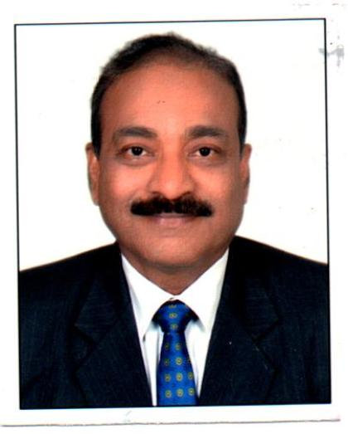

Name : Sunil Kumar Sinha

Educational Qualification : M.Sc. (Botany), DDU University Gorakhpur

Professional Qualification : CAIIB, PGDM, PG Diploma in Financial Management
Certificate in computer literacy from NIIT

About Sunil Kumar Sinha
Mr. Sinha has a 36 Years of rich experience in financial sector. He joined in the Bank as Probationary Officer in Dec. 1982. He has worked in different capacities in Uttar Pradesh and Andhra Pradesh. Mr. Sinha retired as Assistant General Manager (AGM) from the Bank of Baroda Zonal Office, Lucknow in July 2018.

He was also the Nodal Officer on behalf of Bank of Baroda, Eastern UP, Zone representing at Banking Ombudsman, RBI, Lucknow.

He has over decades of expertise in Assessment of credit requirement of different business / Industry segments based on the viability of the project with focus on MSME segment and in providing mentoring support and capacity building of the entrepreneurs in the light of current Govt. guidelines.

He has vast experience and expertise in handling issues of customer complaints related to deficiency in Banking Services.

Contact No. : 9208379115

