ANUJ KUMAR ACHARYA
SENIOR ASSOCIATE

Expertise: Immigration Laws, Private International Laws, Civil & Criminal matters.
Education: L.L.B., (DU), B.A. (German Language) BHU
Membership: Supreme Court Bar Association (SCBA) & Delhi High Court Bar Association (DHCBA)

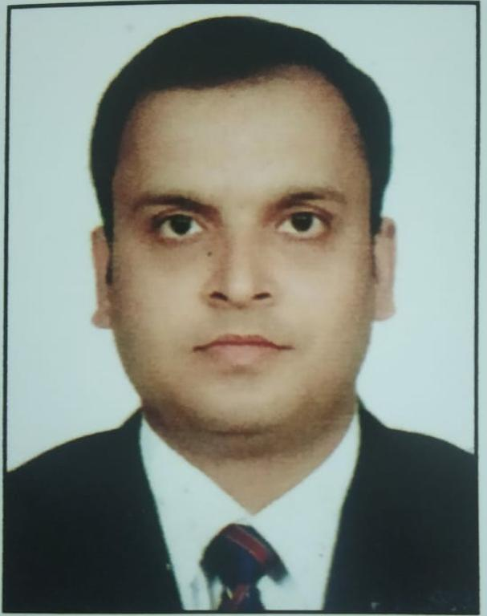

About Anuj Kumar Acharya :
Anuj is a law graduate from the Campus Law Centre (CLC), Faculty of Law, University of Delhi, Delhi. He has an impressive academic background and varied interests. Before pursuing law, he graduated from Banaras Hindu University (BHU) in German Language. He is handling matters and advising firm’s international clients on Immigration Laws and issues concerning Private International Laws, especially German/ EU. He is an expert in Civil & Criminal matters and plans court strategies for the firm.

